EBP Sustainability State Ranking Survey:

Consolidated State Aggregate of Rank-Order Question Results
Figures 1 through 5 below show the results of individual survey respondents’ rank order questions aggregated across the entire state. For each question, individual respondents were asked to rank their top choices from among a list of items. Since each individual was able to choose only one item as their #1 top-ranked choice for a given question, Figures 9 through 13 below show percentage of respondents who ranked a particular item as either their #1 top-ranked choice or their #2 top-ranked choice. Consolidating respondents’ #1 and #2 top-ranked choices together provides a more meaningful relative measure of the importance of each item when aggregated across the entire state.

For example, Figure 1 below shows that 61.2 percent of survey respondents across the entire state chose consumer demand as either their #1 or #2 top-ranked factor related to choosing EBPs, while 32.4 percent of respondents chose availability of ongoing funding from the state as either their #1 or #2 top-ranked factor, and 23.7 percent chose ability to maintain fidelity to the model as either their #1 or #2 top-ranked factor.

Please note that percentages for each item do not add up to 100 percent because the results for #1 and #2 top-ranked choices have been combined.

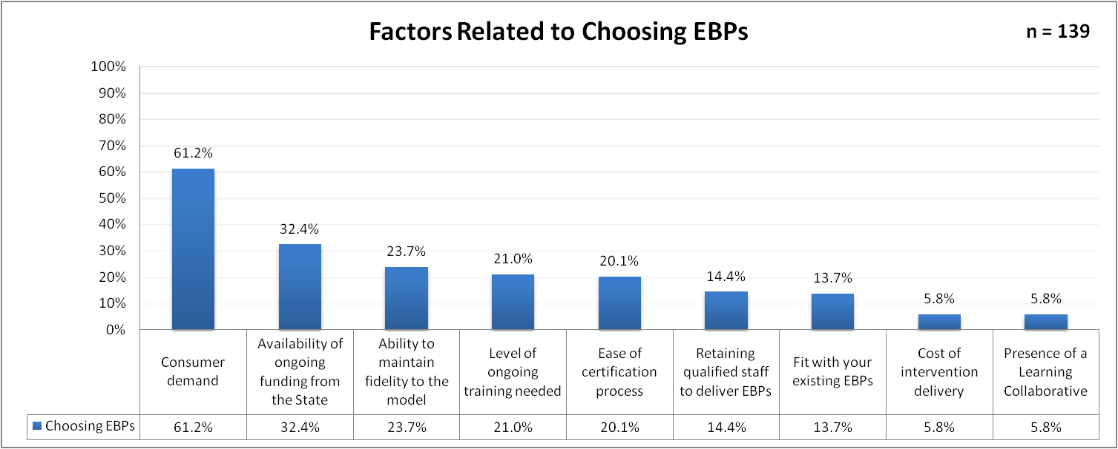
Figure 1: Top-Ranked Factors Related to Choosing EBPs

Figure 2 below shows that 60.4 percent of survey respondents across the entire state chose fund regions to select alternative EBPs based on local needs as either their #1 or #2 top-ranked potential statewide solution for sustaining EBPs, while 26.6 percent of respondents chose certify the CMHSP/Region and not just individuals as either their #1 or #2 top-ranked solution, and 23.7 percent chose provide authoritative EBP consultation as either their #1 or #2 top-ranked solution.

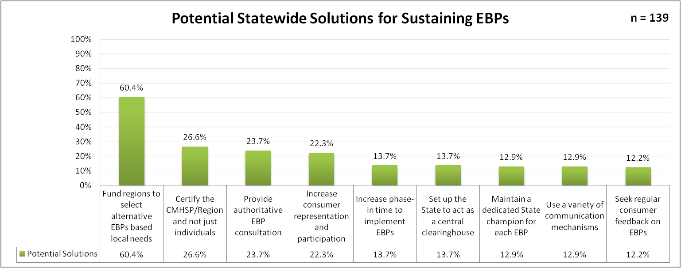
Figure 2: Top-Ranked Potential Statewide Solutions for Sustaining EBPs

Figure 3 below shows that 77.6 percent of survey respondents across the entire state chose promote adaptations of EBPs to accommodate regional differences as either their #1 or #2 top-ranked potential statewide solution for fidelity issues, while 72.4 percent of respondents chose establish more flexible certification standards as either their #1 or #2 top-ranked solution, and 50 percent chose develop audit options to certify the CMHSP/Region not just individuals as either their #1 or #2 top-ranked solution.

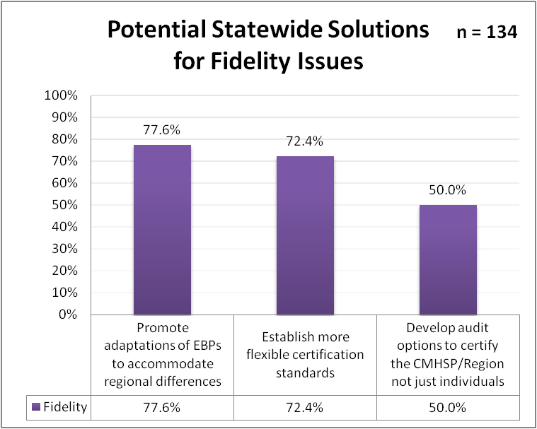
Figure 3: Top-Ranked Potential Statewide Solutions for Fidelity Issues

Figure 4 below shows that 45.7 percent of survey respondents across the entire state chose offer incentives to motivate staff participation in EBP supervision as either their #1 or #2 top-ranked potential statewide solution for staffing issues, while 42.8 percent of respondents chose ensure EBPs don’t add to staff workload as either their #1 or #2 top-ranked solution, and 39.9 percent chose limit the number of EBPs a CMHSP/Region is implementing as either their #1 or #2 top-ranked solution.

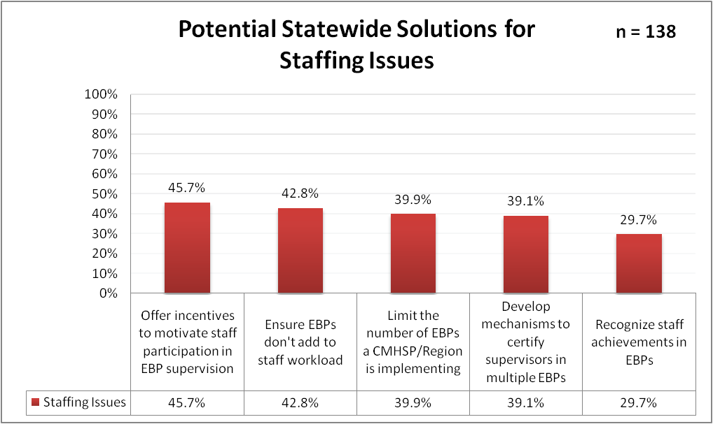
Figure 4: Top-Ranked Potential Statewide Solutions for Staffing Issues

Figure 5 below shows that 76.8 percent of survey respondents across the entire state chose establish common outcome measures for EBPs as either their #1 or #2 top-ranked potential statewide solution for gathering data and measuring outcomes, while 65.9 percent of respondents chose use cost-benefit analysis to determine effectiveness of EBPs as either their #1 or #2 top-ranked solution, and 37.7 percent chose incorporate EBP fidelity measures into State audits as either their #1 or #2 top-ranked solution.

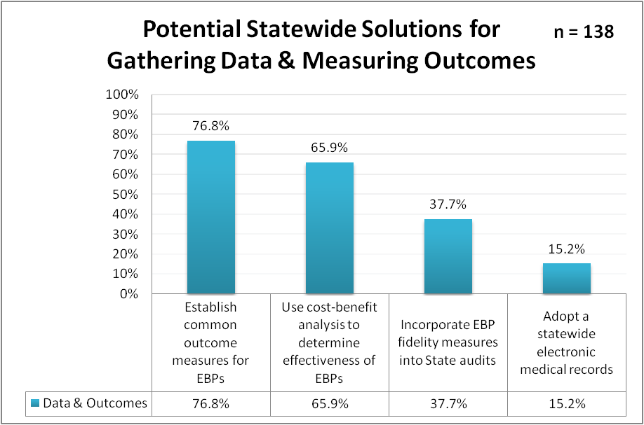
Figure 5: Top-Ranked Potential Statewide Solutions for Gathering Data & Measuring Outcomes

